|  |  |  |
| --- | --- | --- |
| **LAB 321Assignment** | **Type:** | **LongAssignment** |
| **Code:** | **J3.L.P0030** |
| **LOC:** | **600** |
| **Slot(s):** | **15** |

**Title:** chauffeur service

**Background**

A chauffeur is a man employed to drive a passenger motor vehicle, especially a [luxury vehicle](https://en.wikipedia.org/wiki/Luxury_vehicle) such as a large [sedan](https://en.wikipedia.org/wiki/Sedan_(automobile)) or [limousine](https://en.wikipedia.org/wiki/Limousine). A woman employed to drive a passenger motor vehicle is a chauffeuse.

Originally, such drivers were often personal employees of the vehicle owner, but now in many cases specialist chauffeur service companies or individual drivers provide both driver and [vehicle for hire](https://en.wikipedia.org/wiki/Vehicle_for_hire), although there are service companies that just provide the driver.

Reference site:<http://us-123-chauffeur.simplesite.com/>

**Program Specifications**

Program a web site tointroduce your chauffeur services , detail functions of this website is described below

**Features:**

This website contains 3 main functions

* Function 1 : Home page : ( see PIC 01)
  + Display introduction entry ,about us entry and top 3 promotion entries sort by published date
  + Each productcontains
    - Entry name
    - Description picture
    - Entry description
* Function 2 : Gallery ( PIC 02)
  + Display photo about your car
* Function 3 : Contact ( PIC 03)
  + Help user to submit her requests about chauffeur  services

You do not need to write interface for admin control panel, you can add data manually (use SQL SERVER Management studio).

Note: All data must be load from database, not hard code in page.

***Expectation of User interface:***

Pic 01 : Home Page

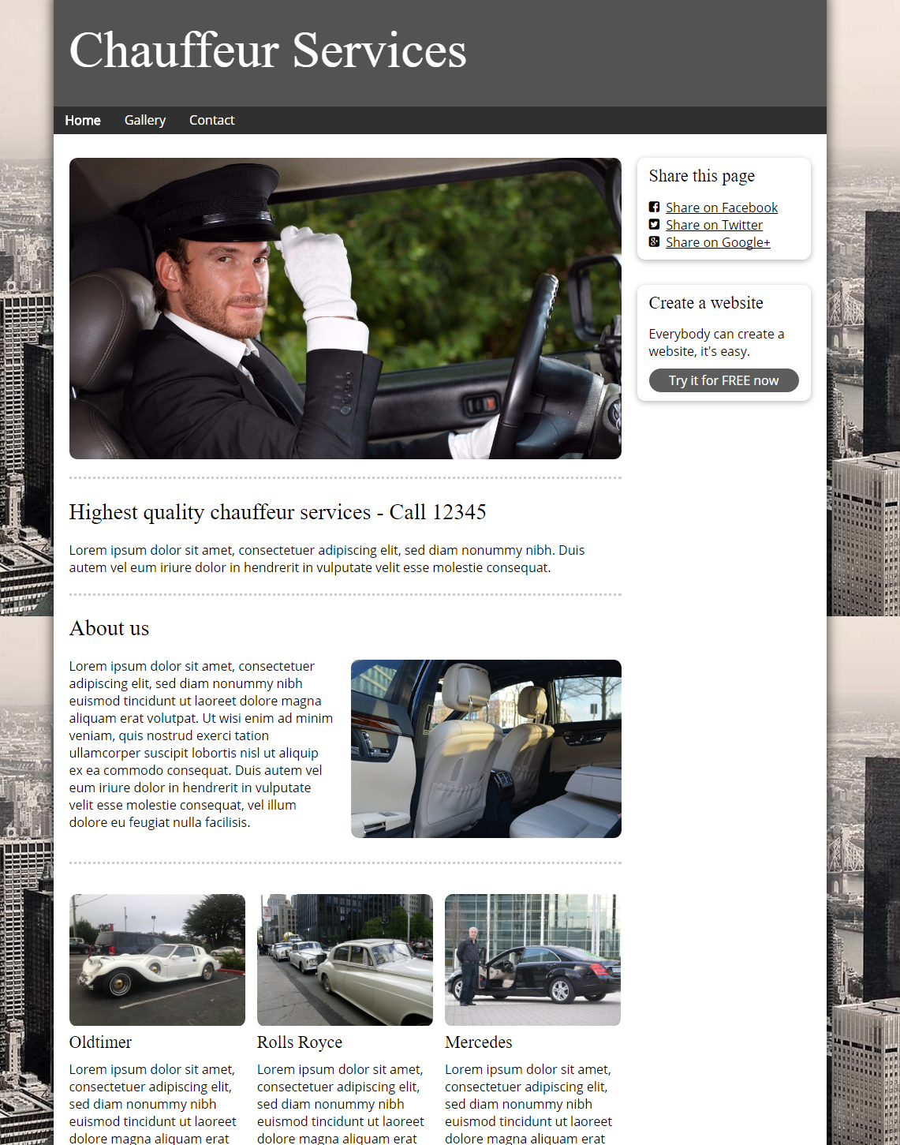

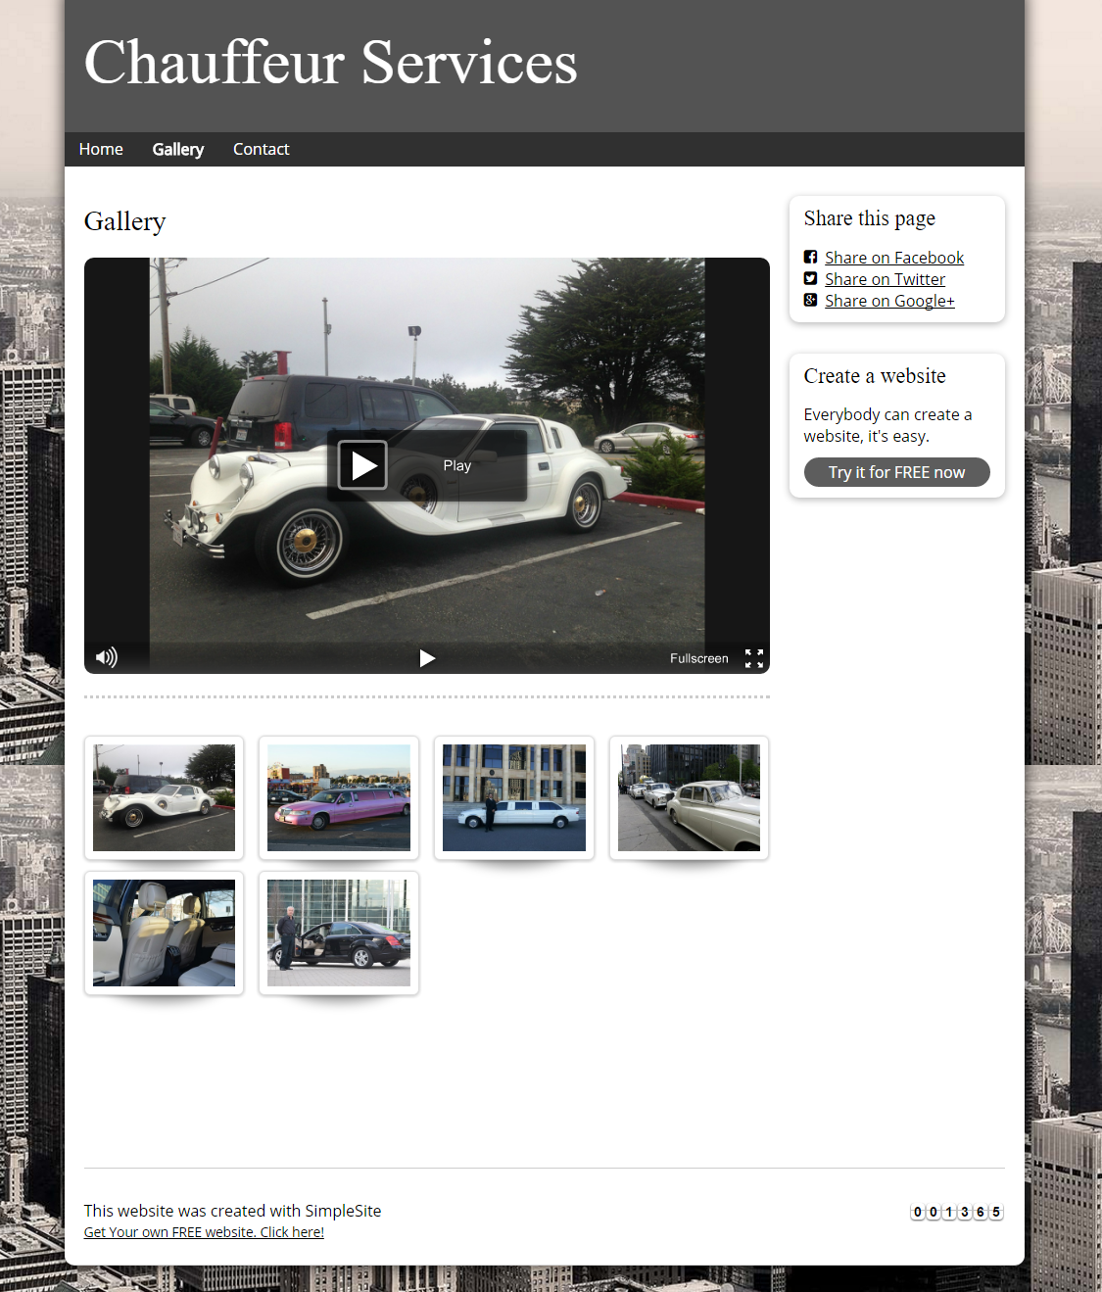

PIC 3 : Contact : allow user to submit message here

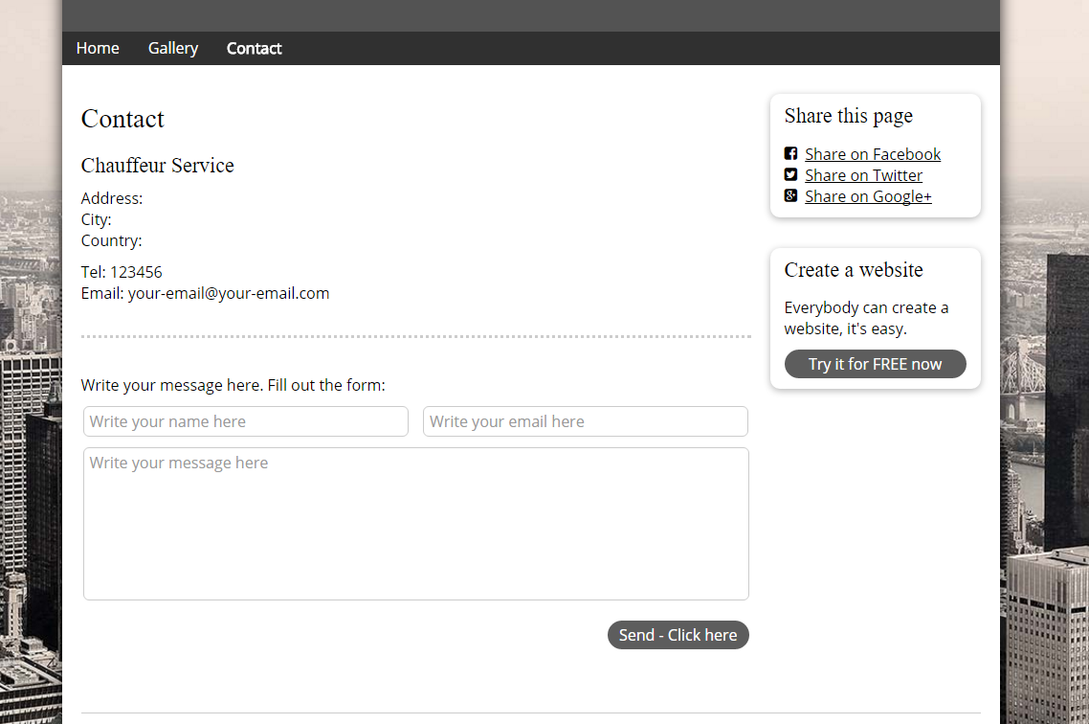

**Guidelines**

* Step 1 : Create web layout
* Step 2 : Create prototype
* Step 3 : Design database base on created prototype
* Step 4 : Code & Test